Instructions for Preparation of Your Paper for the Tenth European Conference on Wood Modification
Philippe Gerardin¹ and Dennis Jones²
¹ LERMAB – EA 4370 USC 1445 INRA, Faculté des Sciences et Technologies. Université de Lorraine, Boulevard des Aiguillettes, B.P. 70239, F-54506 Vandoeuvre-lès-Nancy cedex, France [email: philippe.gerardin@univ-lorraine.fr]
² Wood Science and Engineering Division, Department of Engineering Sciences and Mathematics, Luleå University of Technology, 931 87 Skellefteå, Sweden [email: dennis.jones@ltu.se]
Keywords: List 3 to 7 keywords alphabetically
abstract
This document explains how to prepare your camera-ready manuscript for the Tenth European Conference on Wood Modification. Please read these instructions carefully. Use this template (ECWM10_2022_Paper_template.doc) for preparation of the manuscript, preferably by writing directly and replacing this text. This document is formatted according to the guidelines. If you choose to cut and paste you must paste Unformatted, or otherwise make sure that the final format corresponds to that of the template. Please prepare your manuscript using ‘MS Word’ and NOT as a pdf, if this is not possible contact the proceedings editor. Your manuscript should be submitted electronically as an e-mail attachment to ecwm10@sciencesconf.org no later than 31 December 2021. Papers received after this date may not be considered. After submission, an acknowledgement of receipt will be sent within 3 working days. Please contact the organisers if you wish to submit your paper by mail on a floppy disc, zip disc, or CD. Please make every effort to limit the file size of your manuscript (in particular by reducing the file size of pictures), as this will greatly help the work of the editors in preparing the conference proceedings. All figures and tables should be embedded in the manuscript where possible. If this is not possible, then please supply good quality images by mail with a copy of the manuscript, clearly indicating where the figures, diagrams, etc. are to be placed and ensure that each figure is labelled clearly on the back with author’s name and figure number. The abstract should be no longer than 350 words and be a single paragraph.
introduction
All manuscripts must be in English and use SI units. The organisers of the Tenth European Conference on Wood Modification assume that the manuscript authors grant us the copyright to use the manuscript in the proceedings. Should authors use tables or figures from other publications, they must ensure that they have obtained the copyright permission from the publishers. The margins and formatting are set in the template and in this document, please do not alter the formatting in any way. If text is pasted into the template, then please ensure it does not contain hidden formatting (use the clear formatting command before pasting). Use italic for emphasising text, not boldface, nor capitals, nor underlining. Botanical names should be in italics, as should et al., e.g., en vacuo, etc. Please do not use page numbering, this will be done by the proceedings publisher. The page limit for full presentations is 8 pages and for posters is 4 pages. Please do not exceed these page limits. Although it may be difficult for you to fit everything in the paper that you may wish, it is important that you can carry the conference proceedings home with you! The supplied template should be used to prepare your manuscript, but for the manuscripts for posters, the use of the named headings as given is not obligatory. For manuscripts associated with the full scientific presentations, please adhere to the given named headings wherever possible.
Organisation of the text. Please adhere to the format given in the template wherever possible. Main level headings should use the style ‘ECWM SECTION HEADING’.
Second level headings
These should use the style ‘ECWM subheading 1’
Third level headings
These should use the style ‘ECWM subheading 2’. Please do not use any lower level headings.
Footnotes
Please do not use footnotes, if necessary use a superscript number and refer to that at the end of the text before the references.
Tables
Refer to table in the text as (Table 1, Table 2,….). Tables should be presented in the text, but with a space above and below, so as to avoid confusion with the text. A descriptive title should be placed above the table (use style 'ECWM table title’). Units should be given in square brackets. The font should be 10 pt. and the column headings should be in bold. An example is given below (Table 1).

Table 1: Results of test
Sample | Width [mm] | Height [mm] | Weight [g] | Time [s]
1ª | 2 | 1 | 2.5 | 4
2ª | 3 | 2 | 2.4 | 5
3^{b} | 4 | 3 | 2.4 | 6
4^{b} | 5 | 4 | 2.3 | 7
ªHeat treated, ^{b}Acetylated

Figures
Figures should be embedded in the text, and referred to as (Figure 1, Figure 2, …). Leave a space above and below the figure to avoid confusion with the text. The caption should be placed below the figure (use style ‘ECWM figure title’). An example is given below (Figure 1).

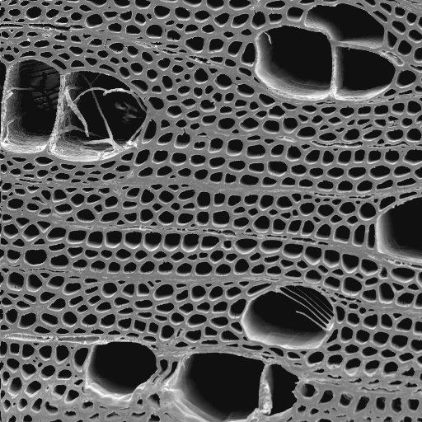
Figure 1: Scanning electron micrograph of birch
Equations
Equations should be referred to in the text as (Eqn. 1, Eqn. 2,….) and indented 5 mm. There should be one line of space above and below the equation, so as to avoid confusion with the text, the equations should be numbered sequentially, and the number put in brackets on the right hand side of the text. An example is given below (Eqn. 1).

WPG (%) = ((M₁ – M₂)/M₁) x 100 (1)

References
All references should contain enough information to enable the reader to find the cited materials. Please pay particular attention to the style for references, since experience has shown that this leads to more editorial queries than anything else! Cite references in the text using the author’s last name and date of publication as follows (Jones 1999, Jones and Evans 1997, Jones et al. 2003). List citations in alphabetical order at the end of the manuscript (examples are given at the end of this document). Please use full journal titles and not abbreviations. Do not link references to other software such as Endnote, since this makes editing of the text very difficult. Any such problems will be referred back to the corresponding author for rectification.
experimental
Text here (block out and type over, use sub-headings as appropriate)
results and discussion
Text here (block out and type over, use sub-headings as appropriate)
conclusions
We hope these guidelines are of use. If you are having any problems then please contact the conference organisers. Please keep to the deadline, and please do not exceed the page limits! We wish you luck and look forward to seeing you at the conference.
acknowledgements
Text here.
references
Forster, S.C. (1998). Decay resistance of modified softwood. PhD Thesis, University of Wales, Bangor, UK.

Green, F., Clausen, C.A., Micales, J.A. Highley, T.L. and Wolter, K.E. (1989). Carbohydrate-degrading complex of brown-rot fungus Postia placenta: Purification of β-1,4-xylanase. Holzforschung, 43(1), 25-31.

Larsson, P. and Tillmann, A.M. (1989). Acetylation of lignocellulosic materials. The International Research Group on Wood Preservation. Document No. IRG/WP/3516.

Matsuda, H. (1996). Chemical modification of solid wood. In: Chemical Modification of Lignocellulosic Materials. Hon, D.N.S. (Ed.), Marcel Dekker, New York, USA, pp. 159-183.

Repellin, V. and Guyonet, R. (2003). Evaluation of heat treated beech by non-destructive testing. In: Proceedings of the First European Conference on Wood Modification. Ghent, Belgium, pp. 73-82.

Rowell, R.M. (Ed.). (1984). The Chemistry of Solid Wood. Advances in Chemistry Series 207, American Chemical Society, Washington DC, USA.

